Chapter 2 Review Questions
SECTION 2.1
R1. List five nonproprietary Internet applications and the application-layer protocols that they use.
The Web: HTTP; file transfer: FTP; remote login: Telnet; e-mail: SMTP; BitTorrent file sharing: BitTorrent protocol
R2. What is the difference between network architecture and application architecture?
Network architecture refers to the organization of the communication process into layers (e.g., the five-layer Internet architecture). Application architecture, on the other hand, is designed by an application developer and dictates the broad structure of the application (e.g., client-server or P2P).
Network Architecture → The overall structure and layers that define how data moves from one device to another (e.g., OSI Model, TCP/IP Model).
Application Architecture → The structure and rules for how a specific application works and exchanges data between client and server (e.g., HTTP, FTP, SMTP).
📌 In one line:
- Network Architecture → The design of the “road” for sending data.
- Application Architecture → The “rules” for running a specific app.

R3. For a communication session between a pair of processes, which process is
the client and which is the server?
The process which initiates the communication is the client; the process that waits to be contacted is the server.
R4. For a P2P file-sharing application, do you agree with the statement, “There is no notion of client and server sides of a communication session”? Why or why not?
No. In a P2P file-sharing application, the peer that is receiving a file is typically the client and the peer that is sending the file is typically the server.
R5. What information is used by a process running on one host to identify a process running on another host?
The IP address of the destination host and the port number of the socket in the destination process.
R6. Suppose you wanted to do a transaction from a remote client to a server as
fast as possible. Would you use UDP or TCP? Why?
If you want to perform a transaction from a remote client to a server as fast as possible, you would generally use UDP (User Datagram Protocol). Here's why:

UDP (User Datagram Protocol)
- Faster: UDP is a connectionless protocol, meaning it doesn’t establish a connection before sending data and doesn't require acknowledgment for every packet sent. This reduces the overhead, making it faster.
- No Retransmission/Guarantees: UDP doesn't guarantee reliable delivery, which means that if some packets are lost, it won't attempt to resend them. This helps reduce latency, which is beneficial for speed but comes at the cost of reliability.
- Lower Overhead: Since UDP doesn’t have the overhead of connection management (like establishing connections, maintaining state, or acknowledgment), it can transfer data much more quickly.

TCP (Transmission Control Protocol)
- Reliable, but slower: TCP is a connection-oriented protocol, meaning it requires handshakes to establish a connection before transmitting data. It also ensures reliable data transfer through acknowledgments and retransmissions in case of packet loss. These features, while ensuring data integrity, add overhead and can slow down the transaction speed.

Why UDP is Better for Speed
- Less overhead: TCP has more control mechanisms like flow control, error checking, and congestion control. These mechanisms, while useful for reliability, slow down the transmission speed. UDP, on the other hand, skips these steps to ensure the fastest transmission.
- Suitable for real-time applications: In scenarios where speed is a priority (e.g., live video streaming, VoIP, or online gaming), UDP is preferred because even if some packets are lost, it doesn’t significantly affect the overall experience as much as the delays caused by retransmissions in TCP.

When to use TCP?
While UDP is faster, TCP is used when reliability is essential. For example, if you need to ensure that a transaction (such as an online banking transfer or a file download) is completed correctly, TCP would be more appropriate because it guarantees that data is received accurately and in the correct order.
R7. Referring to Figure 2.4, we see that none of the applications listed in Figure
2.4 requires both no data loss and timing. Can you conceive of an application
that requires no data loss and that is also highly time-sensitive?
One such example is remote word processing, for example, with Google docs. However, because Google docs runs over the Internet (using TCP), timing guarantees are not provided.
R8. List the four broad classes of services that a transport protocol can provide.
For each of the service classes, indicate if either UDP or TCP (or both) provides such a service.
a) Reliable data transfer TCP provides a reliable byte-stream between client and server but UDP does not.
b) A guarantee that a certain value for throughput will be maintained Neither
c) A guarantee that data will be delivered within a specified amount of time Neither
d) Confidentiality (via encryption) Neither
R9. Recall that TCP can be enhanced with TLS to provide process-to-process
security services, including encryption. Does TLS operate at the transport
layer or the application layer? If the application developer wants TCP to be
enhanced with TLS, what does the developer have to do?
SSL operates at the application layer. The SSL socket takes unencrypted data from the application layer, encrypts it and then passes it to the TCP socket. If the application developer wants TCP to be enhanced with SSL, she has to include the SSL code in the application.
প্রশ্নটা basically দুইটা জিনিস জানতে চাইছে –
- TLS আসলে কোন layer-এ কাজ করে — Transport layer নাকি Application layer?
  - TCP তো transport layer-এর protocol। TLS (Transport Layer Security) নাম শুনে মনে হতে পারে transport layer-এ কাজ করে, কিন্তু আসলে TLS OSI model-এর application layer আর transport layer-এর মাঝে কাজ করে। Networking-এর দৃষ্টিকোণ থেকে TLS-কে সাধারণত application layer-এর অংশ ধরা হয়, কারণ অ্যাপ্লিকেশন লেভেলেই TLS handshake, certificate verification ইত্যাদি হয়।
- TCP-কে TLS দিয়ে enhance করতে চাইলে ডেভেলপারকে কী করতে হবে —
  - মানে, developer যদি চান TCP communication encrypted হোক, তাহলে তাকে অ্যাপ্লিকেশনের কোডে TLS/SSL library (যেমন OpenSSL, Java Secure Socket Extension, Python-এর ssl module ইত্যাদি) ব্যবহার করতে হবে।
  - ডেভেলপারকে TCP socket-এর ওপর TLS "wrap" করতে হয়, যাতে ডাটা পাঠানোর আগে encrypt হয় আর রিসিভ করার পরে decrypt হয়।
  - অর্থাৎ, এটি TCP-এর ভিতরের কাজ নয়, বরং TCP connection establish হওয়ার পরে application-level code TLS ব্যবহার করে secure channel তৈরি করে।
সারকথা:
- TLS → application layer-এ operate করে (transport layer-এর ঠিক উপরে)।
- TCP-এর সাথে TLS ব্যবহার করতে হলে ডেভেলপারকে অ্যাপ্লিকেশনে TLS library integrate করতে হবে।

SECTIONS 2.2–2.5
R10. What is meant by a handshaking protocol?
A protocol uses handshaking if the two communicating entities first exchange control packets before sending data to each other. SMTP uses handshaking at the application layer whereas HTTP does not.
R11. Why do HTTP, SMTP, and IMAP run on top of TCP rather than on UDP?
The applications associated with those protocols require that all application data be received in the correct order and without gaps. TCP provides this service whereas UDP does not.
কারণগুলো একে একে বলি —

1. Reliable data transfer দরকার
- TCP গ্যারান্টি দেয় যে ডাটা ঠিকভাবে, সঠিক ক্রমে পৌঁছাবে (error-free, in-order delivery)।
- HTTP, SMTP, IMAP—সবগুলোতেই ডাটা (যেমন ওয়েবপেজ, ইমেইল) সঠিকভাবে পুরোপুরি না পৌঁছালে কমিউনিকেশন ভেঙে যাবে।
- UDP-তে এই গ্যারান্টি নেই — প্যাকেট হারিয়ে গেলে বা ক্রম বদলে গেলে অ্যাপ্লিকেশন নিজেকে সামলাতে হয়, যা জটিল।

2. Connection-oriented communication দরকার
- TCP একটি connection-oriented প্রোটোকল — প্রথমে সংযোগ (handshake) তৈরি হয়, তারপর ডাটা আদান-প্রদান হয়।
- HTTP-তে ক্লায়েন্ট ও সার্ভারকে একই কনটেক্সটে রিকোয়েস্ট-রেসপন্স বিনিময় করতে হয়।
- SMTP আর IMAP-এও ইমেইল সার্ভারগুলোর মধ্যে একাধিক ধাপে কমান্ড-রেসপন্স হয়, যেটার জন্য স্থায়ী সংযোগ দরকার।

3. Flow control ও congestion control
- TCP স্বয়ংক্রিয়ভাবে sender ও receiver-এর মধ্যে ডাটা ট্রান্সমিশন স্পিড অ্যাডজাস্ট করে।
- UDP-তে এই ব্যবস্থা নেই, ফলে নেটওয়ার্কে কনজেশন বা ডাটা লস বেশি হতে পারে।

4. Large message handling
- ইমেইল বা ওয়েবপেজ অনেক বড় ডাটা ট্রান্সফার করতে পারে, যা UDP-তে ফ্র্যাগমেন্টেশন ইস্যু তৈরি করে।
- TCP স্বয়ংক্রিয়ভাবে ডাটা ভাগ করে পাঠায় এবং রিসিভারে আবার জোড়া লাগায়।
R12. Consider an e-commerce site that wants to keep a purchase record for each of its customers. Describe how this can be done with cookies.
When the user first visits the site, the server creates a unique identification number, creates an entry in its back-end database, and returns this identification number as a cookie number. This cookie number is stored on the user’s host and is managed by the browser. During each subsequent visit (and purchase), the browser sends the cookie number back to the site. Thus the site knows when this user (more precisely, this browser) is visiting the site.
R13. Describe how Web caching can reduce the delay in receiving a requested
object. Will Web caching reduce the delay for all objects requested by a user
or for only some of the objects? Why?

How Web Caching Reduces Delay:
Web caching reduces the delay in receiving a requested object by storing copies of frequently accessed content (like web pages, images, or files) closer to the user, often at intermediate locations like proxy servers, content delivery networks (CDNs), or even the user's browser. When the user requests an object that has been cached, the system can serve the content directly from the cache instead of fetching it from the original server.
This reduces the time spent in:
- Network transmission: No need to travel all the way to the origin server.
- Server processing: The cache already has the object, avoiding repeated processing and fetching from the server.

Will Web Caching Reduce Delay for All Objects?
No, web caching will not reduce the delay for all objects. It works only for cached objects, meaning objects that have been previously requested and stored in the cache. Here's why:
- Cached Objects: If the object is already in the cache, the delay is minimal as it’s served directly from the cache.
- Non-cached Objects: For objects that aren’t cached yet (e.g., the first time a user requests an object or it has expired from the cache), the system must fetch the object from the original server, leading to the usual delay.
R14. Telnet into a Web server and send a multiline request message. Include in the request message the If-modified-since: header line to force a response message with the 304 Not Modified status code.
Telnet is not available in Windows 7 by default. to make it available, go to Control Panel, Programs and Features, Turn Windows Features On or Off, Check Telnet client. To start Telnet, in Windows command prompt, issue the following command > telnet webserverver 80 where "webserver" is some webserver. After issuing the command, you have established a TCP connection between your client telnet program and the web server. Then type in an HTTP GET message. An example is given below:
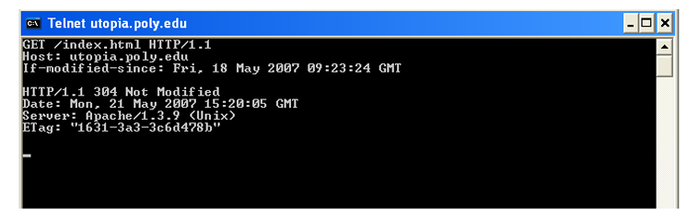
Since the index.html page in this web server was not modified since Fri, 18 May 2007 09:23:34 GMT, and the above commands were issued on Sat, 19 May 2007, the server returned "304 Not Modified". Note that the first 4 lines are the GET message and header lines inputed by the user, and the next 4 lines (starting from HTTP/1.1 304 Not Modified) is the response from the web server.
R15. List several popular messaging apps. Do they use the same protocols as SMS?

Here are some popular messaging apps:
- WhatsApp
- Facebook Messenger
- Telegram
- WeChat
- Signal
- iMessage (Apple devices only)
- Viber
- Line

Do they use the same protocols as SMS?
No — they don’t use the same protocols as SMS.
- SMS (Short Message Service) works over the cellular network’s signaling system (SS7), independent of the internet. It’s built into the GSM/3G/4G/5G mobile standards and usually limited to 160 characters per message.
- Messaging apps like WhatsApp or Telegram use the internet (IP-based communication) rather than cellular signaling. They typically use custom protocols layered on top of TCP/IP, often with end-to-end encryption (e.g., Signal Protocol for WhatsApp and Signal).
- This is why apps require mobile data or Wi-Fi, while SMS just needs a cellular signal.

R16. Suppose Alice, with a Web-based e-mail account (such as Hotmail or Gmail), sends a message to Bob, who accesses his mail from his mail server using IMAP. Discuss how the message gets from Alice’s host to Bob’s host. Be
sure to list the series of application-layer protocols that are used to move the
message between the two hosts.

ধাপে ধাপে প্রক্রিয়া:
- Alice → Webmail Server:
  - Alice তার ব্রাউজারের মাধ্যমে Gmail/Hotmail ওয়েবসাইটে লগইন করে।
  - সে যখন “Send” চাপ দেয়, তখন তার ব্রাউজার HTTP বা HTTPS প্রোটোকলের মাধ্যমে মেইলটি Webmail server-এ পাঠায়।
- Webmail Server → Bob’s Mail Server:
  - Gmail/Hotmail এর মেইল সার্ভার (Alice-এর পক্ষ থেকে) Bob-এর মেইল সার্ভারে মেইল পাঠায়।
  - এই ট্রান্সফার হয় SMTP (Simple Mail Transfer Protocol) ব্যবহার করে।
- Bob’s Mail Server → Bob’s Mailbox:
  - Bob-এর মেইল সার্ভার মেইলটি তার mailbox-এ সংরক্ষণ করে।
- Bob → Bob’s Mail Server:
  - Bob যখন তার মেইল চেক করে (Thunderbird, Outlook, বা অন্য কোনো mail client দিয়ে), সে IMAP (Internet Message Access Protocol) ব্যবহার করে সার্ভার থেকে মেইলটি রিড করে।

R17. Print out the header of an e-mail message you have recently received. How
many Received: header lines are there? Analyze each of the header lines
in the message.

R18. What is the HOL blocking issue in HTTP/1.1? How does HTTP/2 attempt to solve it?

🧩 HOL (Head-of-Line) Blocking Issue in HTTP/1.1:
HTTP/1.1-এ, সাধারণত একটি TCP সংযোগে একবারে একটিই অনুরোধ (request) পাঠানো হয় এবং তার উত্তর (response) না আসা পর্যন্ত পরের অনুরোধ পাঠানো যায় না।
এটাকে বলে Head-of-Line Blocking (HOL Blocking) —
অর্থাৎ, প্রথম request যদি দেরিতে response পায়, তাহলে তার পেছনের সব request-ও অপেক্ষায় থেকে যায়।
🔹 উদাহরণ:
একটি ওয়েবপেজে ১০টা ছবি লোড করতে হবে।
HTTP/1.1 এ যদি এক TCP connection দিয়ে পাঠানো হয়,
তাহলে প্রথম ছবির response না এলে বাকিগুলোও আটকে যাবে।
🔹 ফলাফল:
- ওয়েবপেজ লোড হতে দেরি হয়
- ব্যান্ডউইথ অপচয় হয়
- ব্রাউজারকে একাধিক parallel TCP connection খুলতে হয় (যা অকার্যকর)

⚙️ HTTP/2 এ সমাধান:
HTTP/2 এই সমস্যার সমাধান করে multiplexing এর মাধ্যমে।
Multiplexing মানে হলো — একই TCP সংযোগের ভিতরে একাধিক request ও response একসাথে পাঠানো ও গ্রহণ করা যায়।
🔹 HTTP/2 এর বৈশিষ্ট্য:
- সব ডেটা ফ্রেম (frames) আকারে ভাগ করা হয়।
- প্রতিটি frame-এর একটি stream ID থাকে — ফলে সার্ভার ও ক্লায়েন্ট বুঝতে পারে কোন response কোন request-এর।
- ফলে একটি request দেরি করলেও অন্য request গুলোর ট্রান্সফার থেমে যায় না।

R19. Is it possible for an organization’s Web server and mail server to have
exactly the same alias for a hostname (for example, foo.com)? What would
be the type for the RR that contains the hostname of the mail server?
হ্যাঁ ✅, একটি সংস্থার Web server এবং Mail server-এর একই alias (যেমন foo.com) থাকতে পারে।
DNS সিস্টেমে, একটি ডোমেইন নামের একাধিক রেকর্ড টাইপ (RR type) থাকতে পারে —
যেমন:
- Web server-এর জন্য → A record (যা IP address নির্দেশ করে)
- Mail server-এর জন্য → MX (Mail Exchange) record (যা মেইল সার্ভারের নাম নির্দেশ করে)
🔹 উদাহরণ:

R20. Look over your received e-mails, and examine the header of a message sent from a user with a .edu e-mail address. Is it possible to determine from the
header the IP address of the host from which the message was sent? Do the
same for a message sent from a Gmail account.

✅ Answer (বাংলায়):
হ্যাঁ, অনেক ক্ষেত্রে ই-মেইলের header অংশ থেকে প্রেরকের host IP address জানা যায় — কিন্তু এটি নির্ভর করে ইমেইল কোন সার্ভার দিয়ে পাঠানো হয়েছে তার ওপর।

🧩 1. .edu (Educational) E-mail এর ক্ষেত্রে:
- অনেক বিশ্ববিদ্যালয়ের মেইল সার্ভার নিজেরা পরিচালনা করে।
- তাই header-এ “Received:” লাইনে সাধারণত প্রেরকের host বা client computer-এর IP address দেখা যায়।
উদাহরণ:

SECTION 2.5

R21. BitTorrent Reciprocity
Question:
In BitTorrent, suppose Alice provides chunks to Bob throughout a 30-second interval. Will Bob necessarily return the favor and provide chunks to Alice in this same interval? Why or why not?
Answer (বাংলায়):
- না, Bob অবশ্যই একই সময়ে Alice-কে chunks ফেরত দেবেনা।
- কারণ BitTorrent tit-for-tat principle অনুসরণ করে: peer গুলো মূলত তাদের top uploaders কে data পাঠায়।
- যদি Alice নতুন বা low upload capacity থাকে, Bob হয়তো অন্য peer-কে বেশি priority দিবে।

R22. Alice-এর প্রথম chunk কীভাবে পাবেন?
Question:
Consider a new peer Alice that joins BitTorrent without possessing any chunks. Without any chunks, she cannot become a top-four uploader for any of the other peers, since she has nothing to upload. How then will Alice get her first chunk?
Answer (বাংলায়):
- Alice প্রথম chunk পাবে “optimistic unchoking” থেকে।
- BitTorrent randomly কিছু peers-কে temporarily upload দেয় (regardless of reciprocity), যাতে নতুন peer-রাও প্রথম chunk পেতে পারে।

R23. Overlay Network
Question:
What is an overlay network? Does it include routers? What are the edges in the overlay network?
Answer (বাংলায়):
- Overlay network: একটি logical network যা existing physical network-এর উপর তৈরি হয়।
- Routers: overlay network সাধারণত routers অন্তর্ভুক্ত করে না, শুধুমাত্র end hosts বা peers অন্তর্ভুক্ত।
- Edges: overlay network-এ edge হলো logical link between two nodes, যা physical path ব্যবহার করে messages পাঠায়।

SECTION 2.6

R24. CDN Server Placement Philosophies
Question:
CDNs typically adopt one of two different server placement philosophies. Name and briefly describe them.
Answer (বাংলায়):
- Distributed / Decentralized Placement:
  - সার্ভারগুলো ভূগোলিকভাবে ছড়িয়ে থাকে, user-এর কাছাকাছি।
  - লক্ষ্য: delay কমানো, content দ্রুত provide করা।
- Centralized Placement:
  - Few, central servers; user requests routed centrally।
  - লক্ষ্য: সহজ management, কিন্তু delay বেশি হতে পারে।

R25. CDN Server Selection Factors
Question:
Besides network-related considerations such as delay, loss, and bandwidth performance, there are other important factors that go into designing a CDN server selection strategy. What are they?
Answer (বাংলায়):
CDN server selection-এর জন্য network ছাড়াও গুরুত্বপূর্ণ factors:
- Server load: কতটা busy বা free server আছে।
- Content availability: server-এর কাছে requested content আছে কি না।
- Geographical proximity: user এবং server-এর physical location।
- Reliability / uptime: server কতটা dependable।
- Cost / pricing: কিছু CDN provider cost-efficient server use করে।

Chapter 2 Problems
P1. True or false?
a. A user requests a Web page that consists of some text and three images. For this page, the client will send one request message and receive four response messages.
- False ✅
  - For each object (HTML file + 3 images), the browser sends a separate HTTP request and gets a separate response.
  - That’s 4 request messages and 4 response messages, not 1 request and 4 responses.

b. Two distinct Web pages (e.g., www.mit.edu/research.html and www.mit.edu/students.html) can be sent over the same persistent connection.
- True ✅
  - With persistent HTTP (HTTP/1.1 default), multiple requests/responses can be sent sequentially over the same TCP connection.

c. With nonpersistent connections between browser and origin server, it is possible for a single TCP segment to carry two distinct HTTP request messages.
- False ✅
  - In nonpersistent HTTP, each TCP connection handles only one request-response pair, then closes. So one TCP segment can’t have two different requests.

d. The Date: header in the HTTP response message indicates when the object in the response was last modified.
- False ✅
  - Date: indicates when the response message was generated by the server.
  - The header that indicates last modification time is Last-Modified:.

e. HTTP response messages never have an empty message body.
- False ✅
  - Many responses have no body (e.g., status codes 204 No Content, 304 Not Modified, or HEAD request responses).
Problem 2
SMS, iMessage, WeChat, and WhatsApp are all smartphone real-time messaging systems. After doing some research on the Internet, for each of these systems write one paragraph about the protocols they use. Then write a paragraph explaining how they differ.

Answer:

SMS (Short Message Service)
SMS is a messaging service provided by mobile networks that allows users to send text messages up to 160 characters. SMS operates over the Signaling System 7 (SS7) protocol, which is a standard for exchanging information between telephone switches in the network. It uses circuit-switched networks to deliver messages between users, relying on the mobile carrier’s infrastructure.

iMessage
iMessage is Apple’s messaging service, which works over the Internet and is available on iOS and macOS devices. It uses Apple's proprietary protocol, leveraging push notification services to send messages, and end-to-end encryption to secure them. iMessages are delivered using the Apple Push Notification Service (APNS), and it can also send SMS messages when no internet connection is available.

WeChat
WeChat is a popular messaging app in China, which uses a combination of HTTP and TCP/IP protocols to send messages. It uses a client-server architecture, where messages are sent to WeChat's servers, which then forward them to the intended recipient. WeChat also supports features like voice and video calls, which use WebRTC for real-time communication.

WhatsApp
WhatsApp is a widely used messaging app that operates over the Internet using Voice over IP (VoIP) and WebRTC protocols for voice and video calls. It uses the XMPP (Extensible Messaging and Presence Protocol) for text messaging and supports end-to-end encryption. WhatsApp uses server-client communication to forward messages, and it can work on both mobile data and Wi-Fi networks.
Problem 3
Question:
Consider an HTTP client that wants to retrieve a Web document at a given URL. The IP address of the HTTP server is initially unknown. What transport and application-layer protocols besides HTTP are needed in this scenario?

Easy Answer:
Besides HTTP, the client needs:
- Application-layer protocol:
DNS (Domain Name System) — to translate the website’s domain name (like www.example.com) into its IP address.
- Transport-layer protocol:
TCP (Transmission Control Protocol) — to create a reliable connection between the client and the web server for HTTP communication.
So, the process is:
- Use DNS to get the IP address from the domain name.
- Use TCP to connect to that IP address on port 80 (for HTTP).
- Then use HTTP to request the web page.

Problem 4
Got it! Let’s answer each question by looking at the HTTP GET message you shared:
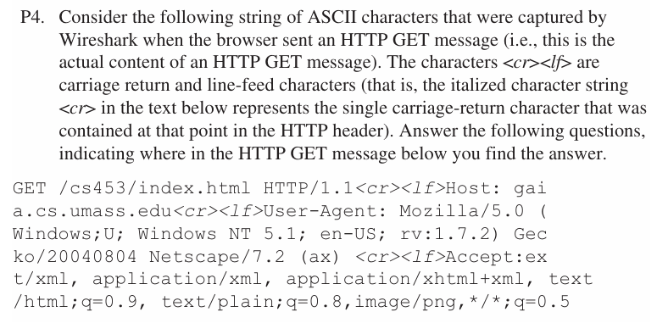
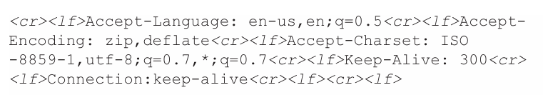

a. What is the URL of the document requested by the browser?
- From the first line:
- GET /cs453/index.html HTTP/1.1
- The requested path is /cs453/index.html.
- From the Host header:
- Host: gaia.cs.umass.edu
- So, the full URL is:
http://gaia.cs.umass.edu/cs453/index.html

b. What version of HTTP is the browser running?
- From the first line again:
- GET /cs453/index.html HTTP/1.1
- The browser is using HTTP version 1.1.

c. Does the browser request a non-persistent or a persistent connection?
- Look at the Connection header:
- Connection: keep-alive
- The value keep-alive means the browser is requesting a persistent connection (the TCP connection will stay open for multiple requests/responses).

d. What is the IP address of the host on which the browser is running?
- This information is NOT present in the HTTP GET message.
- The client’s IP address is part of the TCP/IP packet headers, not the HTTP headers or message body.
- So, you cannot find the client IP in this HTTP GET request.

e. What type of browser initiates this message? Why is the browser type needed in an HTTP request message?
- From the User-Agent header:
- User-Agent: Mozilla/5.0 (Windows;U; Windows NT 5.1; en-US; rv:1.7.2) Gecko/20040804 Netscape/7.2 (ax)
- The browser identifies itself as Netscape 7.2 (Mozilla/5.0) on Windows NT 5.1.
- Why is this needed?
  - Servers use the User-Agent string to tailor content or behavior based on the browser’s capabilities and quirks.
  - For example, the server might send different HTML or scripts to different browsers to ensure proper display and compatibility.

এটা দিয়ে সার্ভার কী করে?
সার্ভার এই তথ্য দেখে ঠিক করে যে তোমাকে কোন ধরণের content পাঠাবে।
👉 উদাহরণ:
- যদি সার্ভার দেখে তুমি মোবাইল থেকে ঢুকছো, তাহলে মোবাইল ফ্রেন্ডলি (responsive বা light-weight) পেজ পাঠাবে।
- যদি দেখে তুমি পুরানো ব্রাউজার ব্যবহার করছো, তবে এমন JavaScript পাঠাবে যা পুরানো ভার্সনেও চলবে।
- আবার কখনো কখনো আলাদা CSS/HTML দিয়ে ডিজাইন টিউন করা হয় যাতে তোমার ব্রাউজারে সঠিকভাবে শো করে।

If you want, I can help you write these answers in a neat format for your assignment!
Problem 5
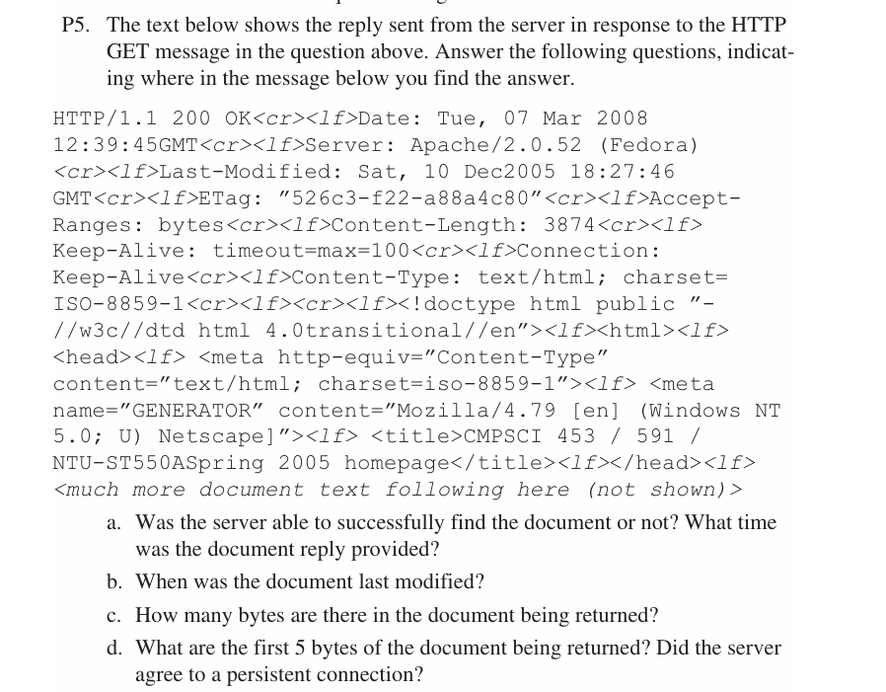
a) The status code of 200 and the phrase OK indicate that the server was able to locate
the document successfully. The reply was provided on Tuesday, 07 Mar 2008
12:39:45 Greenwich Mean Time.

b) The document index.html was last modified on Saturday 10 Dec 2005 18:27:46 GMT.

c) There are 3874 bytes in the document being returned.

d) The first five bytes of the returned document are : <!doc. The server agreed to a
persistent connection, as indicated by the Connection: Keep-Alive field

P6. Obtain the HTTP/1.1 specification (RFC 2616). Answer the following:

a. Explain the mechanism used for signaling between the client and server to indicate that a persistent connection is being closed. Can the client, the server, or both signal the close of a connection?
Answer:
In HTTP/1.1, connections are persistent by default. If either side wants to close the connection after completing the current request/response, it includes the header:
Connection: close
This signals that the connection will be closed once the transaction ends.
✔️ Both the client and the server can signal the closing of a connection.

b. What encryption services are provided by HTTP?
Answer:
HTTP itself does not provide any encryption services. It is a plaintext protocol. If encryption or security is required, HTTP is combined with SSL/TLS, which is then known as HTTPS. So, HTTP alone has no built-in encryption.

c. Can a client open three or more simultaneous connections with a given server?
Answer:
According to RFC 2616, a client should not open more than two simultaneous connections per server. This rule was introduced to improve performance while avoiding congestion on the Internet.
✔️ Therefore, opening three or more simultaneous connections is not allowed under the HTTP/1.1 specification.

d. Either a server or a client may close a transport connection between them if either one detects the connection has been idle for some time. Is it possible that one side starts closing a connection while the other side is transmitting data via this connection? Explain.
Answer:
Yes, it is possible. Since HTTP runs over TCP, a connection can be half-closed. If one side decides to close an idle connection while the other side is still sending data, the transmission may be interrupted. This can lead to data loss or a reset if the closure is not properly synchronized.
✔️ To avoid such issues, RFC 2616 recommends using timeouts and careful connection management (e.g., keep-alive timeout).
Problem 7
Suppose within your Web browser you click on a link to obtain a Web page. The IP address for the associated URL is not cached in your local host, so a DNS lookup is necessary to obtain the IP address. Suppose that n DNS servers are visited before your host receives the IP address from DNS; the successive visits incur an RTT of RTT1, . . . , RTTn. Further suppose that the Web page associated with the link contains exactly one object, consisting of a small amount of HTML text. Let RTT0 denote the RTT between the local host and the server containing the object. Assuming zero transmission time of the object, how much time elapses from when the client clicks on the link until the client receives the object?

এখন সময় গণনা করতে হবে:
যখন তুমি লিঙ্কে ক্লিক করলে থেকে object পাওয়া পর্যন্ত:
- DNS lookup time = RTT1 + RTT2 + … + RTTn
- TCP connection establish (3-way handshake) = RTT0
- HTTP request পাঠানো + HTML object response পাওয়া = RTT0
👉 তাই মোট সময় হবে:
Total time=(RTT1+RTT2+…+RTTn)+2×RTT0
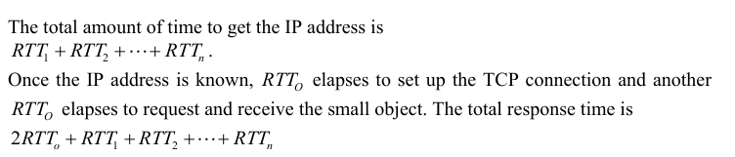
Problem 8
Referring to Problem P7, suppose the HTML file references eight very small objects on the same server. Neglecting transmission times, how much time elapses with
a. Non-persistent HTTP with no parallel TCP connections?
b. Non-persistent HTTP with the browser configured for 6 parallel connections?
c. Persistent HTTP?
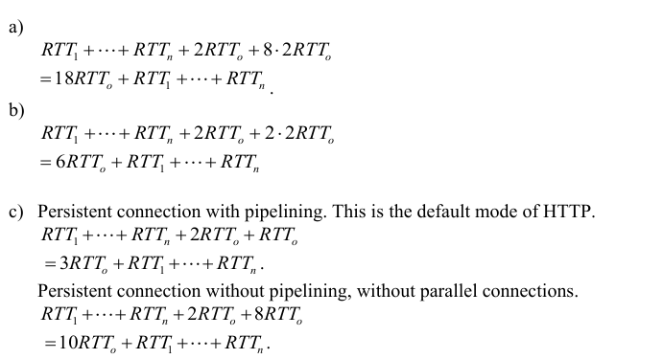
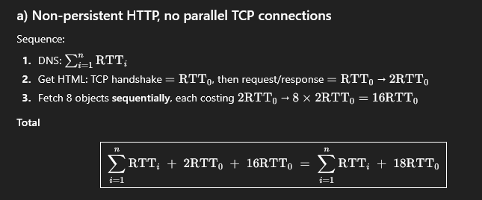
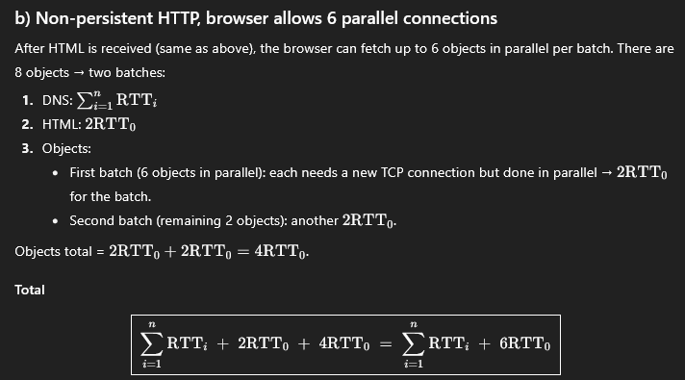
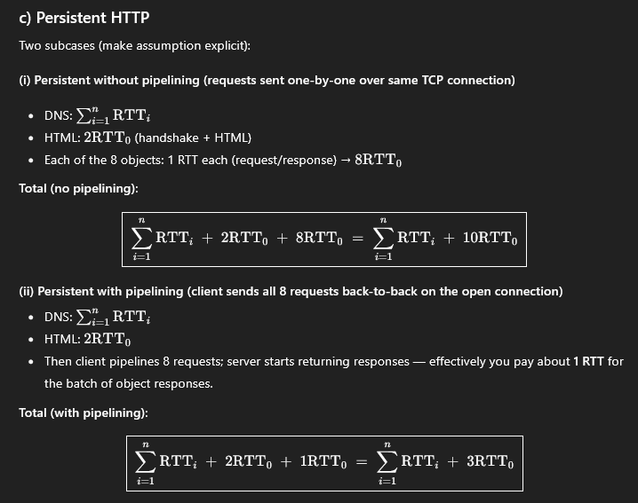
Problem 9
Consider Figure 2.12, for which there is an institutional network connected to the Internet. Suppose that the average object size is 1,000,000 bits and that the average request rate from the institution’s browsers to the origin servers is 16 requests per second. Also suppose that the amount of time it takes from when the router on the Internet side of the access link forwards an HTTP request until it receives the response is three seconds on average (see Section 2.2.5). Model the total average response time as the sum of the average access delay (that is, the delay from Internet router to institution router) and the average Internet delay. For the average access delay, use /(1- b), where is the average time required to send an object over the access link and b is the arrival rate of objects to the access link.
a. Find the total average response time.
b. Now suppose a cache is installed in the institutional LAN. Suppose the miss rate is 0.4. Find the total response time.
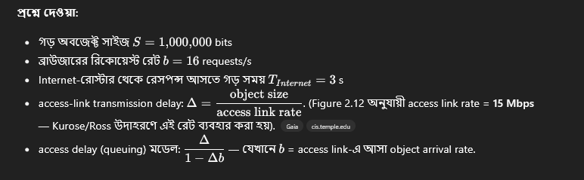
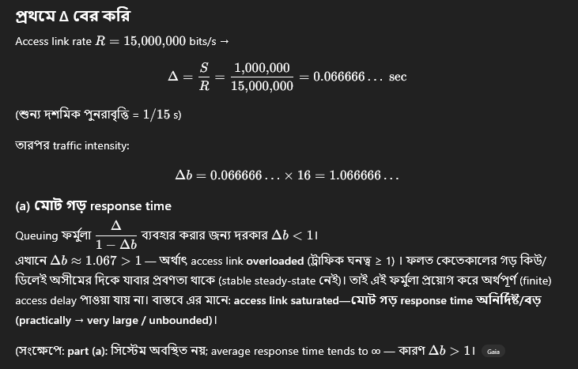
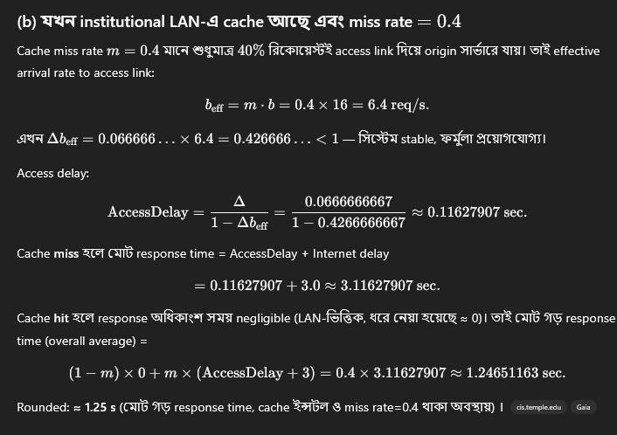
Problem 10
P10. Consider a short, 10-meter link, over which a sender can transmit at a rate of 150 bits/sec in both directions. Suppose that packets containing data are100,000 bits long, and packets containing only control (e.g., ACK or handshaking) are 200 bits long. Assume that N parallel connections each get1/N of the link bandwidth. Now consider the HTTP protocol, and suppose that each downloaded object is 100 Kbits long, and that the initial downloaded object contains 10 referenced objects from the same sender. Would parallel downloads via parallel instances of non-persistent HTTP make sense in this case? Now consider persistent HTTP. Do you expect significant gains over the non-persistent case? Justify and explain your answer.

প্রশ্নে যা দেওয়া আছে
- লিংকের দৈর্ঘ্য: 10 মিটার (এত ছোট যে propagation delay প্রায় শূন্য ধরা যায়)
- ডাটা রেট: 150 bits/sec (দুই দিকেই একই)
- ডাটা প্যাকেট (একটি অবজেক্ট) = 100,000 bits (100 Kbits)
- কন্ট্রোল প্যাকেট = 200 bits
- প্রথম অবজেক্টে আরও 10টি referenced অবজেক্ট আছে (সব একই সার্ভার থেকে আসবে)
- Non-persistent HTTP: প্রতি অবজেক্টের জন্য নতুন TCP কানেকশন তৈরি হয়
- Persistent HTTP: একবার কানেকশন তৈরি করে সব অবজেক্ট পাঠানো হয়
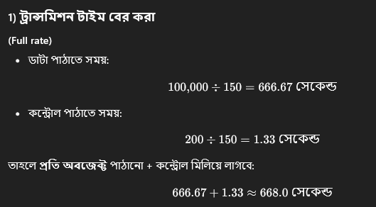
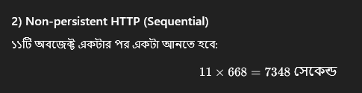
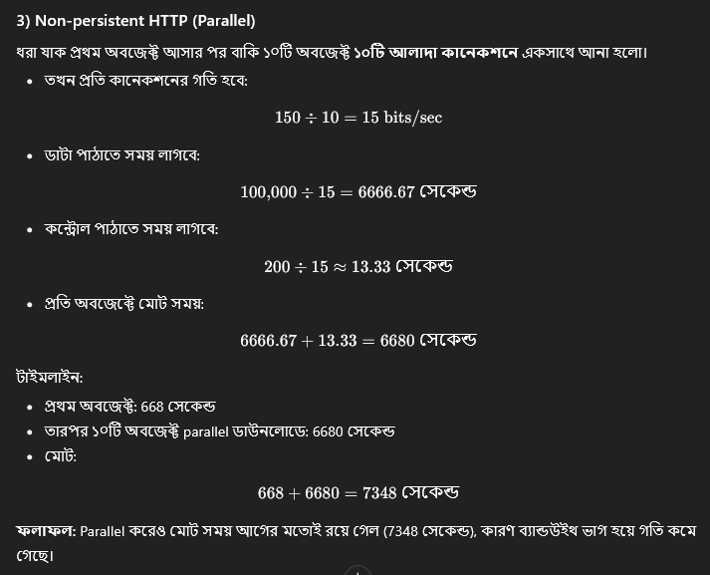
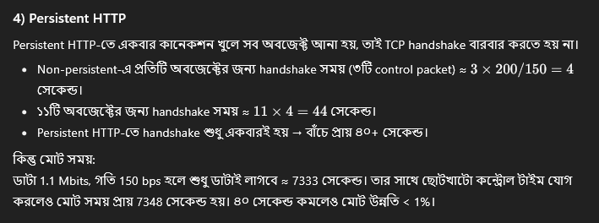
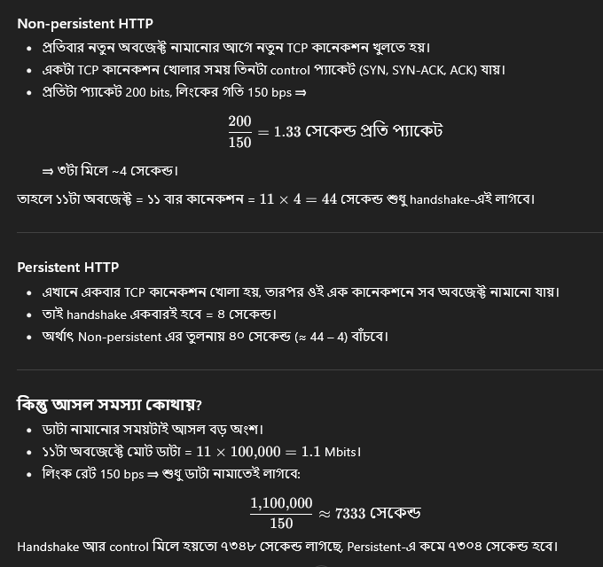
Problem 11
Consider the scenario introduced in the previous problem. Now suppose that the link is shared by Bob with four other users. Bob uses parallel instances of non-persistent HTTP, and the other four users use non-persistent HTTP without parallel downloads.
a. Do Bob’s parallel connections help him get Web pages more quickly? Why or why not?
b. If all five users open five parallel instances of non-persistent HTTP, then would Bob’s parallel connections still be beneficial? Why or why not?
a) Yes, because Bob has more connections, he can get a larger share of the link bandwidth.
b) Yes, Bob still needs to perform parallel downloads; otherwise he will get less bandwidth than the other four users.

P13. Consider sending over HTTP/2 a Web page that consists of one video clip, and five images. Suppose that the video clip is transported as 2000 frames, and each image has three frames.
a. If all the video frames are sent first without interleaving, how many “frame times” are needed until all five images are sent?
a) No interleaving (all 2000 video frames first): the images (5 × 3 = 15 frames) can only go after.
Total frame times until all images finish = 2000 + 15 = 2015.
b. If frames are interleaved, how many frame times are needed until all five images are sent.

(b) Interleaving হলে
- আমাদের আছে:
  - 1টা ভিডিও স্ট্রিম (2000 ফ্রেম)
  - 5টা ইমেজ স্ট্রিম (প্রতিটা 3 ফ্রেম = মোট 15 ফ্রেম)
- Interleaving মানে হলো ভিডিও আর ইমেজ ফ্রেমগুলো একসাথে পালা করে পাঠানো।
  - ধরা যাক 6টা স্ট্রিম (১টা ভিডিও + ৫টা ইমেজ) রাউন্ড-রবিন করে চলছে।
  - প্রতি রাউন্ডে 6 ফ্রেম পাঠানো হবে (ভিডিওর ১টা + প্রতিটা ইমেজের ১টা করে)।
- এখন, প্রতিটা ইমেজের দরকার 3টা ফ্রেম।
  - প্রথম ফ্রেম যাবে 1–6 সময়ের মধ্যে,
  - দ্বিতীয় ফ্রেম যাবে 7–12 সময়ের মধ্যে,
  - তৃতীয় ফ্রেম যাবে 13–18 সময়ের মধ্যে।
👉 সুতরাং, সব ইমেজ শেষ হয়ে যাবে 18 ফ্রেম টাইম এর মধ্যে।

P14. Consider the Web page in problem 13. Now HTTP/2 prioritization is employed. Suppose all the images are given priority over the video clip, and that the first image is given priority over the second image, the second image over the third image, and so on. How many frame times will be needed until the second image is sent?
If all images are strictly prioritized over the video, and within the images the priority order is 1 → 2 → 3 → 4 → 5, the server will send image-1’s 3 frames first, then image-2’s 3 frames next.
So image-2 completes after frames:
- image-1: frame times 1,2,3
- image-2: frame times 4,5,6
👉 Therefore the second image is fully sent by frame time 6.

P15. What is the difference between MAIL FROM: in SMTP and From: in the mail message itself?
Answer:
- MAIL FROM:
→ এটি SMTP envelope command, যা প্রেরকের (sender) return address নির্দেশ করে।
→ এটি ব্যবহার করা হয় ডেলিভারি প্রসেসে (delivery process), অর্থাৎ সার্ভার জানে কোথায় error বা bounce message পাঠাতে হবে।
→ উদাহরণ:
- MAIL FROM:<sender@example.com>
- From:
→ এটি message header field, যা ইমেইল কনটেন্টের ভেতরে থাকে এবং ইমেইলটি ব্যবহারকারীর দৃষ্টিতে কে পাঠিয়েছে তা নির্দেশ করে।
→ এটি SMTP ট্রান্সফারের অংশ নয়, বরং message body-এর অংশ।
→ উদাহরণ:
- From: Imamul Anan <anan@example.com>
📌 মূল পার্থক্য:
MAIL FROM: হল envelope-level sender (for delivery) আর From: হল header-level sender (for display to the user)।
SMTP সার্ভার MAIL FROM: ব্যবহার করে delivery পরিচালনা করে, আর মেইল ক্লায়েন্ট From: ব্যবহার করে প্রেরক প্রদর্শন করে।

P16. How does SMTP mark the end of a message body? How about HTTP? Can HTTP use the same method as SMTP to mark the end of a message body? Explain.
Answer:
- SMTP:
→ SMTP মেসেজ বডির শেষ নির্দেশ করতে ব্যবহার করে:
- <CRLF>.<CRLF>
অর্থাৎ, একটি একক ডট (.) যা আলাদা লাইনে থাকে।
এটি বোঝায় মেইল বডি শেষ হয়েছে।
- HTTP:
→ HTTP মেসেজ বডির শেষ নির্দেশ করে Content-Length header দিয়ে, অথবা কিছু ক্ষেত্রে chunked transfer encoding ব্যবহার করে।
→ উদাহরণ:
- Content-Length: 1024
অর্থাৎ, সার্ভার জানে কত বাইট পর্যন্ত পড়তে হবে।
- Can HTTP use SMTP’s method?
❌ না, HTTP SMTP-এর মতো <CRLF>.<CRLF> ব্যবহার করতে পারে না।
কারণ:
  - HTTP message body বাইনারি ডেটা (binary data) ধারণ করতে পারে, যেখানে ডট প্যাটার্ন সহজেই থাকতে পারে।
  - ফলে, <CRLF>.<CRLF> থাকলেও সেটি কন্টেন্টের অংশ নাকি শেষ চিহ্ন — তা বোঝা কঠিন হবে।

P20. Question (English)
Suppose you can access the caches in the local DNS servers of your department. Can you propose a way to roughly determine the Web servers (outside your department) that are most popular among the users in your department? Explain.
Answer (Bangla):
হ্যাঁ, আপনি প্রায়শই departmental users-এর মধ্যে কোন external Web server সবচেয়ে জনপ্রিয় তা অনুমান করতে পারেন local DNS cache বিশ্লেষণ করে:
- Local DNS cache access করুন:
  - Local DNS server সম্প্রতি resolved করা domain names cache-এ সংরক্ষণ করে।
- Frequency বিশ্লেষণ করুন:
  - Cache-এ প্রতিটি external domain কতবার দেখা গেছে তা গণনা করুন।
  - যেসব domain সবচেয়ে বেশি দেখা গেছে, সেগুলো departmental users-এর মধ্যে সবচেয়ে বেশি access হয়েছে।
- Interpretation:
  - উদাহরণ: যদি google.com cache-এ 120 বার দেখা যায়, youtube.com 85 বার এবং facebook.com 90 বার দেখা যায়, তাহলে বোঝা যায় google.com সবচেয়ে জনপ্রিয়।
⚠️ লক্ষ্য করুন: এটি একটি প্রায় অনুমান। Cache entry-এর TTL (Time-To-Live) অনুযায়ী পুরানো entry expire হতে পারে, তাই সব recent access দেখা নাও যেতে পারে।

P21. Question (English)
Suppose that your department has a local DNS server for all computers in the department. You are an ordinary user (i.e., not a network/system administrator). Can you determine if an external Web site was likely accessed from a computer in your department a couple of seconds ago? Explain.
Answer (Bangla):
না, একজন ordinary user হিসেবে আপনি নির্ভরযোগ্যভাবে নির্ধারণ করতে পারবেন না যে departmental কোনো computer কয়েক সেকেন্ড আগে কোনো external Web site access করেছে কি না। কারণ:
- Access restriction:
  - শুধু network/system administrator-রা local DNS server-এর detailed cache access করতে পারে।
- Cache limitation:
  - Cache-এ কেবল resolved domain names থাকে, কোন user কখন access করেছে তা দেখা যায় না।
- Conclusion:
  - আপনি শুধু দেখতে পারবেন যে কোনো domain-এর IP cached আছে কি না। কিন্তু recent access বা specific user-এর activity trace করা সম্ভব নয়।
কেবল network/system administrators যারা DNS log বা real-time monitoring tools ব্যবহার করে, তারা recent accesses জানতে পারবেন।

P22. Consider distributing a file of F = 20 Gbits to N peers. The server has an upload rate of us = 30 Mbps, and each peer has a download rate of di = 2 Mbps and an upload rate of u. For N = 10, 100, and 1,000 and u = 300 Kbps, 700 Kbps, and 2 Mbps, prepare a chart giving the minimum distribution time for each of the combinations of N and u for both client server distribution and P2P distribution.

P23. Client-Server File Distribution
Consider distributing a file of F bits to N peers using a client-server architecture. Assume a fluid model where the server can simultaneously transmit to multiple peers, transmitting to each peer at different rates, as long as the combined rate does not exceed (u_s).
a. Suppose that (u_s / N \le d_{\min}). Specify a distribution scheme that has a distribution time of (NF/u_s).
b. Suppose that (u_s / N \ge d_{\min}). Specify a distribution scheme that has a distribution time of (F/d_{\min}).
c. Conclude that the minimum distribution time is in general given by (\max(NF/u_s, F/d_{\min})).

P24. P2P File Distribution
Consider distributing a file of F bits to N peers using a P2P architecture. Assume a fluid model. For simplicity assume that (d_{\min}) is very large, so that peer download bandwidth is never a bottleneck.
a. Suppose that (u_s \le (u_s + u_1 + \dots + u_N)/N). Specify a distribution scheme that has a distribution time of (F/u_s).
b. Suppose that (u_s \ge (u_s + u_1 + \dots + u_N)/N). Specify a distribution scheme that has a distribution time of (NF/(u_s + u_1 + \dots + u_N)).
c. Conclude that the minimum distribution time is in general given by (\max(F/u_s, NF/(u_s + u_1 + \dots + u_N))).

P25. Overlay Network
Consider an overlay network with N active peers, with each pair of peers having an active TCP connection. Additionally, suppose that the TCP connections pass through a total of M routers. How many nodes and edges are there in the corresponding overlay network?
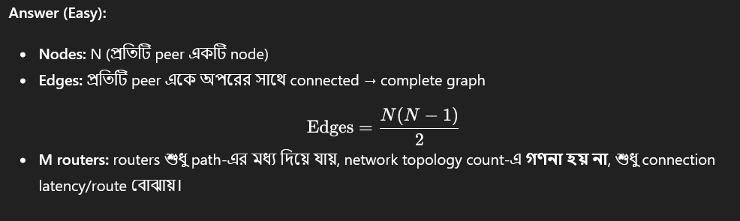

P26. BitTorrent Free-Riding
Suppose Bob joins a BitTorrent torrent, but he does not want to upload any data to any other peers (so-called free-riding).
a. Bob claims that he can receive a complete copy of the file that is shared by the swarm. Is Bob’s claim possible? Why or why not?
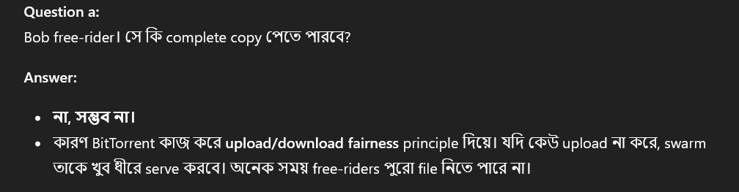
b. Bob further claims that he can make his “free-riding” more efficient by using a collection of multiple computers (with distinct IP addresses) in the computer lab in his department. How can he do that?
Question b:
Bob multiple computers ব্যবহার করে free-riding আরও efficient করতে চায়। কিভাবে?
Answer:
- সে একাধিক computers (প্রতিটি ভিন্ন IP) ব্যবহার করে swarm-এ multiple identities তৈরি করতে পারে।
- প্রতিটি computer আলাদা peer হিসেবে behave করবে → swarm থেকে বেশি pieces download করতে পারবে।
এটা network etiquette/ethical নয়।

P27. DASH System
Consider a DASH system for which there are N video versions (at N different rates and qualities) and N audio versions (at N different rates and qualities). Suppose we want to allow the player to choose at any time any of the N video versions and any of the N audio versions.
a. If we create files so that the audio is mixed in with the video, so the server sends only one media stream at a given time, how many files will the server need to store (each a different URL)?
Question a:
Audio এবং video mix করে single stream করলে server কতগুলো file store করবে?
Answer:
- N video versions × N audio versions
Files needed=N×N
b. If the server instead sends the audio and video streams separately and has the client synchronize the streams, how many files will the server need to store?
Question b:
Audio এবং video আলাদা stream হলে?
Answer:
- Server শুধু N video + N audio files store করবে
Files needed=N+N=2N

P28. TCP and UDP Programs
Install and compile the Python programs TCPClient and UDPClient on one host and TCPServer and UDPServer on another host.
a. Suppose you run TCPClient before you run TCPServer. What happens? Why?
a. TCPClient run করলে TCPServer-এর আগে
- What happens: TCPClient connection তৈরি করতে চেষ্টা করবে, কিন্তু server চলছে না → connection fail হবে বা error দেখাবে।
- Why: TCP connection establish করার জন্য server অবশ্যই listening mode-এ থাকতে হবে। Client server না থাকলে connect করতে পারে না।
b. Suppose you run UDPClient before you run UDPServer. What happens? Why?
b. UDPClient run করলে UDPServer-এর আগে
- What happens: Client message পাঠাতে পারবে, কিন্তু server এখনো receive করতে পারবে না।
- Why: UDP connection connectionless → server না থাকলেও client data send করতে পারে। কিন্তু message reception তখন possible হবে না।
c. What happens if you use different port numbers for the client and server sides?
c. Different port numbers ব্যবহার করলে
- Client এবং server port mismatch হবে → communication হবে না।
- Client অবশ্যই server-এর listening port-এ message পাঠাতে হবে।

P29. UDP Socket Binding
Suppose that in UDPClient.py, after we create the socket, we add the line:
clientSocket.bind(('', 5432))
Will it become necessary to change UDPServer.py? What are the port numbers for the sockets in UDPClient and UDPServer? What were they before making this change?

P30. Browser Simultaneous Connections
Can you configure your browser to open multiple simultaneous connections to a Web site? What are the advantages and disadvantages of having a large number of simultaneous TCP connections?
উত্তর:
- হ্যাঁ, আধুনিক ব্রাউজার সাধারণত এক ডোমেইনে 6–8টি simultaneous connection খোলার অনুমতি দেয়।
- সুবিধা:
  - দ্রুত page load হয় (একসাথে অনেক resource যেমন image, CSS, JS download হয়)।
  - available bandwidth ভালোভাবে ব্যবহার করা যায়।
- অসুবিধা:
  - network congestion বাড়তে পারে।
  - server overload বা throttling এর সম্ভাবনা।
  - client side-এ resource usage (CPU, memory) বেশি হয়।

P31. TCP vs UDP Sockets
We have seen that Internet TCP sockets treat the data being sent as a byte stream, but UDP sockets recognize message boundaries. What is one advantage and one disadvantage of a byte-oriented API versus having the API explicitly recognize and preserve application-defined message boundaries?
প্রশ্ন:
TCP sockets data কে byte stream হিসেবে handle করে, কিন্তু UDP sockets message boundaries preserve করে। Byte-oriented API-এর একটি সুবিধা ও অসুবিধা কী?
উত্তর:
- Byte-oriented (TCP) সুবিধা:
  - Continuous stream → বড় বা variable-length data handle করা সহজ।
- Byte-oriented (TCP) অসুবিধা:
  - Application নিজেই message boundaries manage করতে হবে।
- Message-oriented (UDP) সুবিধা:
  - Application-defined message boundaries automatically preserved হয়।
- Message-oriented (UDP) অসুবিধা:
  - Message size network MTU দ্বারা সীমিত; বড় data হলে fragmentation প্রয়োজন।

P32. Apache Web Server
What is the Apache Web server? How much does it cost? What functionality does it currently have? You may want to look at Wikipedia to answer this question.
উত্তর:
- কি: Apache HTTP Server হলো একটি জনপ্রিয় open-source Web server।
- দাম: Free, open-source।
- Functionality:
  - Static এবং dynamic web page serve করতে পারে।
  - বিভিন্ন modules support করে (PHP, SSL, authentication, URL rewriting)।
  - Logging, virtual hosts, load balancing করতে পারে।
  - Cross-platform support (Linux, Windows, macOS)।

